**SSD Disks**

SSD stands for Solid State Drive. Data and files are stored in tiny microchips in size. Every type of SSD has a controller that reads and writes data and determines the speed of these disks.[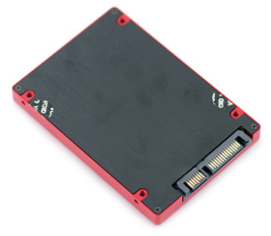](https://techknowledgi.com/wp-content/uploads/2013/03/Corsair-Force-GT-bottom1.jpg)[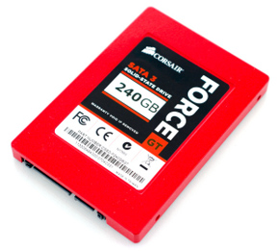](https://techknowledgi.com/wp-content/uploads/2013/03/Corsair-Force-GT-240GB1.jpg)

SSD drives come in standard sizes of 1.8, 2.5 and 3.5 inches and are connected to the motherboard via a SATA or mini-SATA connection that is often found in laptops.

**HDD storage disks**

**HDD is an abbreviation for Hard Disk Drive, and it is an old technology that is still used to this day, as it first appeared in 1956, meaning that this technology is approximately 57 years old. These discs use a magnetic needle head and moving parts inside, so you hear the sound of the hard drive when it is working intensely. The speed of rotation of these disks is about 5400 rpm or 7200 and some of them reach 15,000 rpm, but these disks are mostly intended for servers.**

**The advantage of this type of disk is that it comes with large capacities, as 1 TB is very common these days and is cheap compared to SSDs.**

[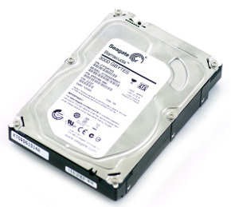](https://techknowledgi.com/wp-content/uploads/2013/03/Seagate-Barracuda-XT-3TB1.jpg)

HDDs come in standard sizes of 2.5 and 3.5 inches and often use SATA connection.

|  |  |  |
| --- | --- | --- |
| Feature | **HDD discs** | **SSD Disks** |
| Power/Battery Consumption | Power consumption of 6-7 watts | 2 - 3 watts of power consumption, which increases battery life |
| the price | Cheap (about $0.075 per gigabyte) | Expensive (about $1 per gigabyte) |
| Storage space | High capacity up to 4TB | Less capacity up to 512 GB for laptops |
| Estimated time to enter the system | 40 seconds average | 22 seconds average |
| sound and vibration | There are sounds and vibrations due to the moving parts inside | No sounds or vibrations |
| heat generated | Higher than SSD disks due to moving parts and higher power consumption | Low heat due to no moving parts and low energy consumption |
| The life span | 1.5 million hours | 2 million hours |
| Read and write speed | 50 to 120 Mbps | 200 to 500 megabytes per second |
| File opening speed | slower than SSD | Much faster than HDD |
| Affected by the magnetic field? | The magnetic field can completely erase the data | Not affected |

**Comparison of the two types**

: احمد ابراهيم نعيم مسامح

: 2019902186

**SSD hard disk features**

1. The way an SSD hard drive works is better than an HDD

The main difference between the two types is in the way they are made. Conventional hard disk drives are small disks that spin with a code embedded in the magnetosphere to store data. On the other hand, SSD drives use memory and thus are a great solution for portable devices like laptops.

2. Longer SSD hard disk life

The life of a conventional hard disk drive is about 25% shorter than that of an ssd hard disk due to the presence of moving parts in a conventional hard disk.

3. Faster booting speed in SSD hard disk

Conventional hard drives require a warm-up period before they can start working properly due to the moving parts they contain. The average startup time for a system with SSD storage is 10-13 seconds, and a comparable boot time for a system with a storage hard drive is 30-40 seconds. It is at least three times slower.

4. SSD hard drive is faster in reading and writing operations

These types have a much higher read/write speed, which means faster uploads and downloads of data and this can almost double in some cases. Research shows that HDDs read and write between 50-120MB/sec compared to SSD drives that read/write a minimum of 200MB/sec and can reach speeds of 2,000MB/sec, which is huge by comparison.

5. Open files faster with SSD

. The file opening speed is about 30% faster than the hard disk as well. This results in more processes and an overall more efficient system.

6. Less SSD power used

Tests show that HDDs consume approximately 50% more power than SSDs, which affects battery life as well as electricity bills. Additionally, SSDs produce less heat which can be important in environments where heat affects equipment performance.

7. Provide a quiet working environment

Moving parts of hard disk drives cause the system to emit some noise while operating the system as well as vibrate in some cases. Because SSD drives are flash-powered, their operation is silent and quiet.

Finally, solid state drives provide faster load times for games, applications, and movies. Moreover, thanks to the technology used, SSDs are relatively light, more portable and able to withstand movement or drops.